### Browser Compatibility Test:

This is how the website will be displayed or run on different browser. It is very important to check whether site UI element of the site working as expected or not and if not the showing the differences among those result.

|  |  |  |  |  |  |
| --- | --- | --- | --- | --- | --- |
| No | Test Title | Pre-condition | Test Steps | Expected Results | Actual results |
| 7 | Browser compatibility  (Cross Browser) | Run your site in different browser | Enter the URL in browser and take screenshot | Screenshot taken | As expected |



Figure 15: view from Google Chrome browser

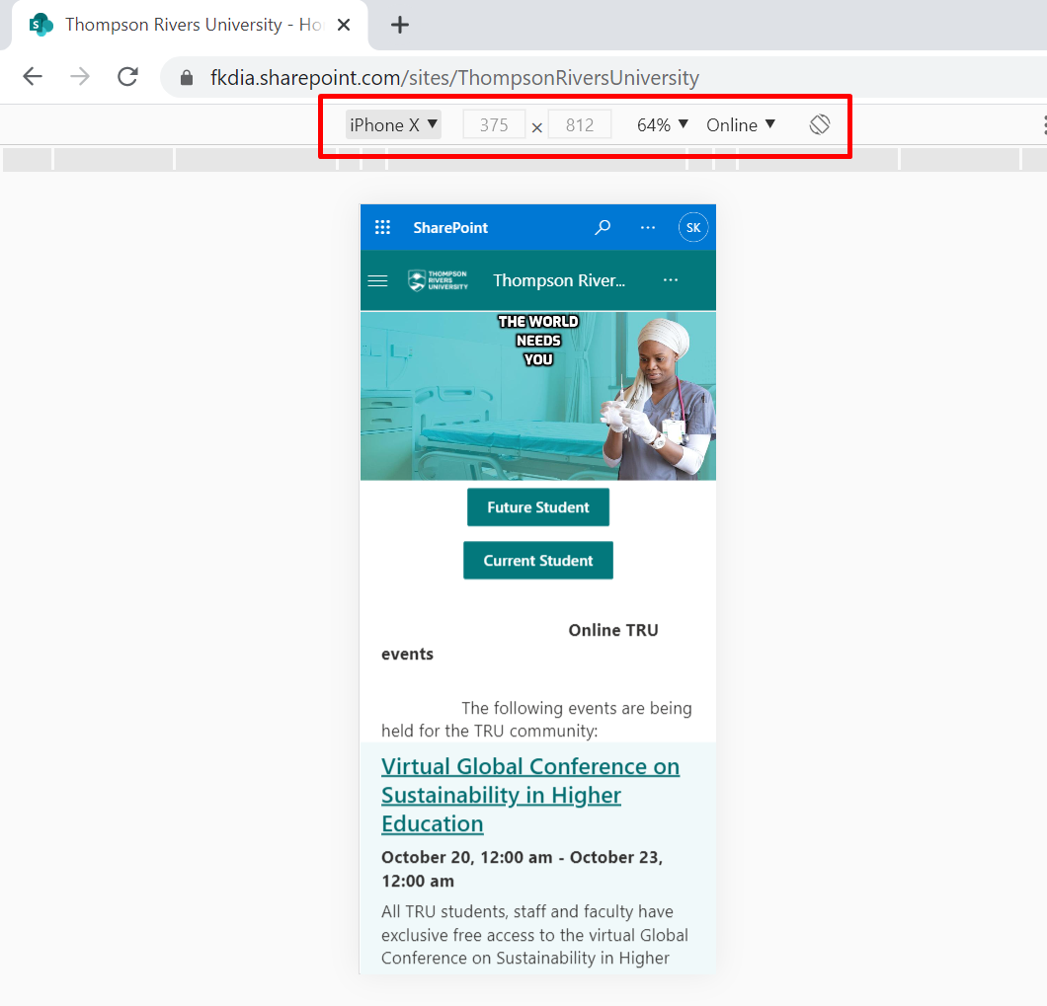

Figure 15: iPhone X device view

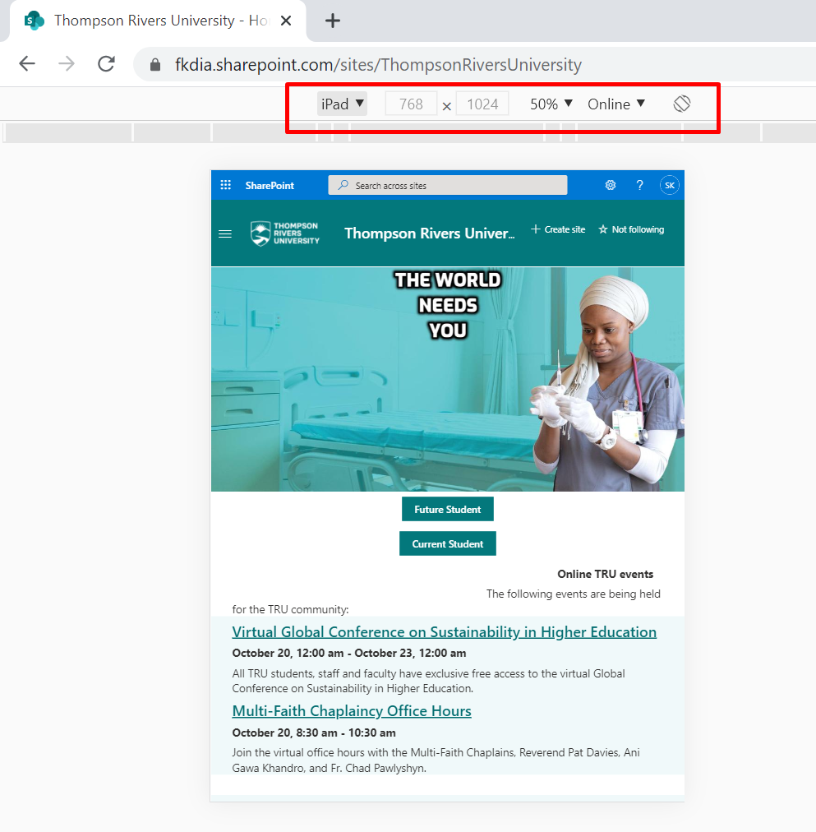

Figure 16: iPad view of the website